***Brain MRI Images for Brain Tumor Detection using AI on jetson nano***

By **“WISAM WAEEL SHAMOON KAKOOZ “**

**Summary:**

A **brain tumor** occurs when abnormal cells form within the [brain](https://en.wikipedia.org/wiki/Human_brain). There are two main types of [tumors](https://en.wikipedia.org/wiki/Tumor): malignant tumors and [benign](https://en.wikipedia.org/wiki/Benign_tumor) (non-cancerous) tumors. These can be further classified as [primary tumors](https://en.wikipedia.org/wiki/Primary_tumor), which start within the brain, and [secondary](https://en.wikipedia.org/wiki/Metastasis) tumors, which most commonly have spread from tumors located outside the brain, known as [brain metastasis](https://en.wikipedia.org/wiki/Brain_metastasis) tumors. All types of brain tumors may produce symptoms that vary depending on the size of the tumor and the part of the brain that is involved. Where symptoms exist, they may include [headaches](https://en.wikipedia.org/wiki/Headaches), [seizures](https://en.wikipedia.org/wiki/Seizures), problems with [vision](https://en.wikipedia.org/wiki/Visual_perception), [vomiting](https://en.wikipedia.org/wiki/Vomiting) and [mental](https://en.wikipedia.org/wiki/Cognition) changes. Other symptoms may include difficulty walking, speaking, with sensations, or [unconsciousness](https://en.wikipedia.org/wiki/Unconsciousness).

**Artificial intelligence & Tumor detection:**

I have used artifical intelligence technology available on Jetson Nano devices, especially the computer vision "classification" technique for the purpose of

diagnosing brain tumors in MRI and i chose to use a RESNET18 model that cosist of 18 layer & skip connection.

* The dataset made of MRI scans of brain divided into train, validation and testing .
* The AI model that used for this project is resnet18 " have 18 layer" finally the model will show two classes ( yes, no )

**" yes " >>** mean there is a tumor in the brain

**" no " >>** mean there is **not** tumor in the brain

* Number of epochs = **180**
* The accuracy of the model = **69.84**
* Time of training, validation & testing on jetson nano = **6 h**
* --batch-size= **1**
* --workers=**1**

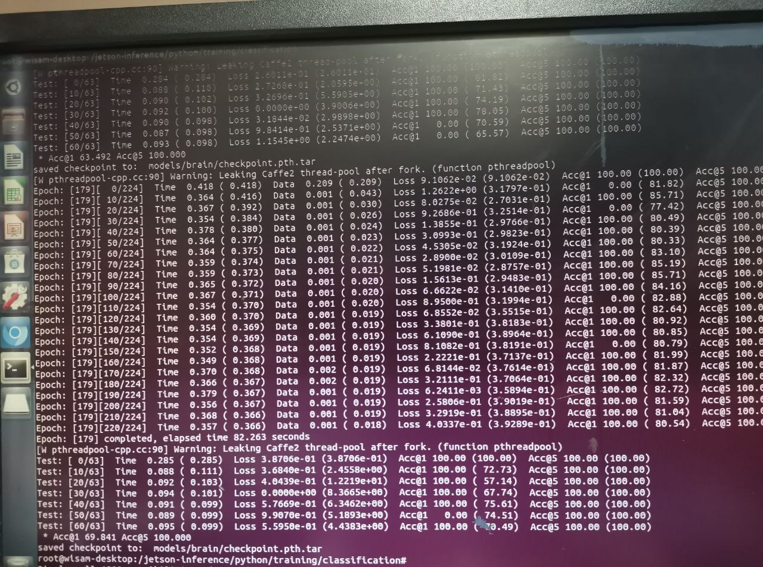

Fig1” show number of epochs used for training for diagnosis of tumors in the brain and the place where the checkpoint.pth.tar file saved”

* The code will be in Resources section in this file

**The Results:**

A Tumor is **a solid mass of tissue that forms when abnormal cells group together**.

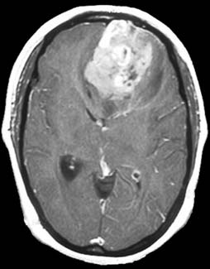

Fig2 “MRI image of brain with tumor mass on the top “

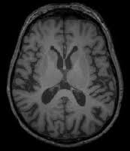

Fig3 “MRI image of brain without tumor mass “

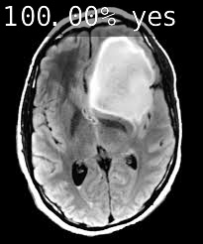

Fig4 “MRI image of brain with diagnosis of tumor mass on the top right by using artificial intelligence with a mark **yes** and the ratio of confidence in diagnosis “

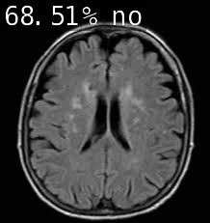

Fig5 “MRI image of brain with diagnosis of **no** tumor mass by using artificial intelligence with a mark **no** and the ratio of confidence in diagnosis “

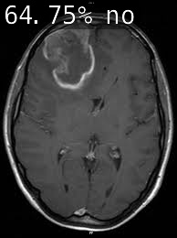

Fig6 “MRI image with **wrong diagnosis no**, and there is a tumor mass on the top left of the image“

**Conclusion:**

The use of artificial intelligence technology on jetson nano has a good results for accuracy 69.84 ,by using about 100 MRI images for each class . the diagnostic errors like in "Fig6" in the model can be avoided by increasing the number of images during training.

**Resources:**

**Code & instructions that followed >>**

[*https://github.com/dusty-nv/jetson-inference/blob/master/docs/pytorch-cat-dog.md*](https://github.com/dusty-nv/jetson-inference/blob/master/docs/pytorch-cat-dog.md)

<https://youtu.be/sN6aT9TpltU?list=PL5B692fm6--uQRRDTPsJDp4o0xbzkoyf8&t=5>

<https://en.wikipedia.org/wiki/Brain_tumor>

**Dataset Source >>**

<https://www.kaggle.com/datasets/navoneel/brain-mri-images-for-brain-tumor-detection>